St Andrew’s
Kirk Ella

Wedding Preparation
2024

Table for Contents

Website 3
Up-to-date Details 3
Application Form for Marriage 3
Banns 4
Passport Details 4
Wedding Fees 4
Marriage Service 5
Bible Readings 7
Wedding Hymns and Music 13
Imported Singers and Musicians 22
Organist 22
Bells 22
Rehearsal 23
Car Parking 23
Seating arrangements 23
Wedding Flowers 24
Crèche 25
Photographers 25
Video 25
Confetti 25
Wedding Checklist 26
Useful numbers 26

Website

Do have a look at our website – www.kirkellachurch.com. It will give you lots of information about what is happening at St Andrew’s. Also, if you need another copy of this booklet you will find it in the ‘Gathering’ tab and then ‘Life Events’ and under ‘Getting married at St Andrew’s’.

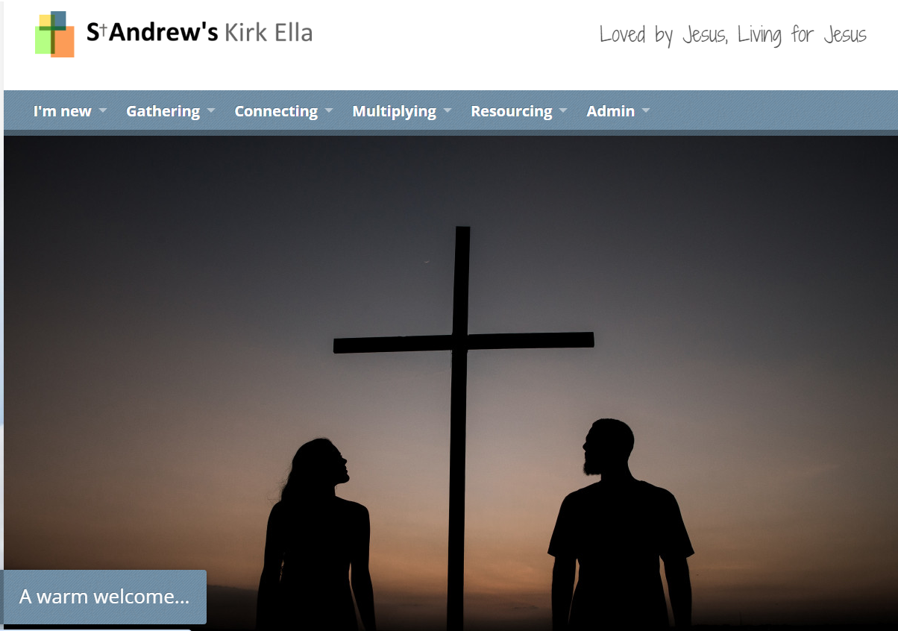

Up-to-date details

As it is now a few months since you booked your wedding date with us, it would be helpful if you could complete the ‘Up-to-date details’ form – Appendix 1 – and return it to us this evening.

Application Form for Marriage

In order for us to complete the Banns and Marriage documents we need certain information from you. It is critical that this is accurate and must agree with your passport. These will be the details on your marriage certificate. An example of how to complete the application form is shown in Appendix 2a. The application form is Appendix 2b.

Banns

It is a legal requirement to have your banns called here at St Andrew’s and if you don’t live in the parish you will need to arrange to have your banns called at your local Church of England Church. To find your local church visit ‘achurchnearyou.com’. You can start this process straight away. Your banns will be read on three consecutive Sundays during a three month period before your wedding date, and once done your local church will issue you with a certificate. This certificate needs to be passed to Liz. If we do not receive the certificate we will not be able to marry you. If you have trouble getting hold of your local church please let us know.

Here at St Andrew’s your banns will usually be read at the 10.45 am service on the 2nd, 3rd and 4th Sundays of the month, two months before your wedding, so if you’re marrying in July your banns will be read in May.

Passport Details

Recently there have been changes to the Marriage Law which now requires all British citizens who are to be married by the publication of banns, to produce evidence to show that they are EEA nationals. We have to comply with this law, so we need to check your passport. This form is Appendix 3.

Wedding Fees

The table of fees for 2023 weddings can be found at Appendix 4.

Marriage Service

It is your responsibility to print the service sheet but the layout and content should be agreed with the member of clergy conduction your service before you go to print.

Music on the way in: __________________________________

What happens next depends on how many hymns you choose . . . (strictly speaking the Church of England marriage service has the talk before the marriage, so you may wish to switch these round)

Two hymns  Hymn 1 _______________  Marriage  Bible Reading  Talk  Prayers  Hymn 2 _____________ | Three hymns  Hymn 1 _______________  Marriage  Hymn 2 _______________  Bible Reading  Talk  Prayers  Hymn 3 _______________ | Four hymns  Hymn 1 ______________  Marriage  Hymn 2 _______________  Bible Reading  Talk  Hymn 3 _______________  Prayers  Hymn 4 _______________

Music during the signing of the registers: ____________________________________________

Music on the way out: ___________________________________________________________

Some wording you may like to put at the front of your service sheet:

For roughly a thousand years the people of Kirk Ella have met together in this building to celebrate the beginning of a new marriage or the birth of a child or the loss of someone dearly loved. We're celebrating today and joining in with a grand tradition that stretches back through ten centuries.
At a traditional English church wedding we don't do everything exactly the same as the way that they do in Hollywood. We can't usually rely on the weather and so we're always inside rather than in a beautiful rose garden with the ocean gently stirring beside the lawn. We sometimes welcome the bridesmaids first; or if we're being more traditional the bride comes first followed by her bridesmaids.
As the service begins you will find that we are either marrying the couple immediately; and then talking about what we have done afterwards; or we talk first and then come to the formal part of the ceremony after a few minutes.
When we come to the formal and legal part of the service it's worth knowing what's going to happen. This may be your first ever church wedding; what they do in films is not exactly what we do around here.
What's the overall shape of the ceremony? What's going to happen?
A church wedding has three parts:
1. Consent to marry: The minister will ask Stephen and Janet if they each give their consent to marry the other. You will hear them say "I will" rather than "I do."
2. Vows: We will then witness the vows that Stephen and Janet make to each other. This form of words has been used for many centuries.
3. The exchange of rings: We will see them each give and receive a ring as a permanent public reminder of their vows.
Enjoy the ceremony. Join with us in praying for the couple. Pray that the hands and hearts that come together today in marriage will gladly stay together for the rest of their lives. Thank you.

Sample service sheets can be found in Appendix 5a, 5b and 5c.

Bible Readings Suitable for a
Wedding Service

Bible reading suggestions
Here is a selection of bible readings which are suitable for a wedding service. You are welcome to choose other bible readings in discussion with us – but here’s a good starting point. As your marriage service is a church service, the only readings that are permitted are from the Bible. If you have a poem that is special to you both, we suggest that you have this read at your reception or you have it printed at the back of your service sheet for your guests to read in their own time.

Old Testament

Genesis 1.26-28
²⁶Then God said, “Let us make man in our image, in our likeness, and let them rule over the fish of the sea and the birds of the air, over the livestock, over all the earth, and over all the creatures that move along the ground.”
²⁷ So God created man in his own image,
in the image of God he created him;
male and female he created them.
²⁸God blessed them and said to them, “Be fruitful and increase in number; fill the earth and subdue it. Rule over the fish of the sea and the birds of the air and over every living creature that moves on the ground.” (NIV)

Genesis 2.20b-25
²²But for Adam no suitable helper was found. ²¹So the LORD God caused the man to fall into a deep sleep; and while he was sleeping, he took one of the man’s ribs and closed up the place with flesh. ²²Then the LORD God made a woman from the rib he had taken out of the man, and he brought her to the man.
²³The man said,
“This is now bone of my bones
and flesh of my flesh;
she shall be called ‘woman,’
for she was taken out of man.”
²⁴For this reason a man will leave his father and mother and be united to his wife, and they will become one flesh.
²⁵The man and his wife were both naked, and they felt no shame. (NIV)

Ecclesiastes 4.7-12
⁷Again I saw something meaningless under the sun:
⁸ There was a man all alone;
he had neither son nor brother.
There was no end to his toil,
yet his eyes were not content with his wealth.
“For whom am I toiling,” he asked,
“and why am I depriving myself of enjoyment?”
This too is meaningless—
a miserable business!
⁹ Two are better than one,
because they have a good return for their work:
¹⁰ If one falls down,
his friend can help him up.
But pity the man who falls
and has no one to help him up!
¹¹ Also, if two lie down together, they will keep warm.
But how can one keep warm alone?
¹² Though one may be overpowered,
two can defend themselves.
A cord of three strands is not quickly broken. (NIV)

Jeremiah 31.31-34
³¹ “The time is coming,” declares the LORD,
“when I will make a new covenant
with the house of Israel
and with the house of Judah.
³² It will not be like the covenant
I made with their forefathers
when I took them by the hand
to lead them out of Egypt,
because they broke my covenant,
though I was a husband to them,”
declares the LORD.
³³ “This is the covenant I will make with the house of Israel
after that time,” declares the LORD.
“I will put my law in their minds
and write it on their hearts.
I will be their God,
and they will be my people.
³⁴ No longer will a man teach his neighbour,
or a man his brother, saying, ‘Know the LORD,’
because they will all know me,
from the least of them to the greatest,”
declares the LORD.
“For I will forgive their wickedness
and will remember their sins no more.” (NIV)
New Testament

John 2.1-11
¹On the third day a wedding took place at Cana in Galilee. Jesus’ mother was there, ²and Jesus and his disciples had also been invited to the wedding. ³When the wine was gone, Jesus’ mother said to him, “They have no more wine.”
⁴“Dear woman, why do you involve me?” Jesus replied. “My time has not yet come.”
⁵His mother said to the servants, “Do whatever he tells you.”
⁶Nearby stood six stone water jars, the kind used by the Jews for ceremonial washing, each holding from twenty to thirty gallons.
⁷Jesus said to the servants, “Fill the jars with water”; so they filled them to the brim.
⁸Then he told them, “Now draw some out and take it to the master of the banquet.”
They did so, ⁹and the master of the banquet tasted the water that had been turned into wine. He did not realize where it had come from, though the servants who had drawn the water knew. Then he called the bridegroom aside ¹⁰and said, “Everyone brings out the choice wine first and then the cheaper wine after the guests have had too much to drink; but you have saved the best till now.”
¹¹This, the first of his miraculous signs, Jesus performed at Cana in Galilee. He thus revealed his glory, and his disciples put their faith in him. (NIV)

John 15.1-8
Jesus said to his disciples:
¹“I am the true vine, and my Father is the gardener. ²He cuts off every branch in me that bears no fruit, while every branch that does bear fruit he prunes so that it will be even more fruitful. ³You are already clean because of the word I have spoken to you. ⁴Remain in me, and I will remain in you. No branch can bear fruit by itself; it must remain in the vine. Neither can you bear fruit unless you remain in me.
⁵“I am the vine; you are the branches. If a man remains in me and I in him, he will bear much fruit; apart from me you can do nothing. ⁶If anyone does not remain in me, he is like a branch that is thrown away and withers; such branches are picked up, thrown into the fire and burned. ⁷If you remain in me and my words remain in you, ask whatever you wish, and it will be given you. ⁸This is to my Father’s glory, that you bear much fruit, showing yourselves to be my disciples. (NIV)

John 15.9-17
Jesus said to his disciples:
⁹“As the Father has loved me, so have I loved you. Now remain in my love. ¹⁰If you obey my commands, you will remain in my love, just as I have obeyed my Father’s commands and remain in his love. ¹¹I have told you this so that my joy may be in you and that your joy may be complete. ¹²My command is this: Love each other as I have loved you. ¹³Greater love has no one than this, that he lay down his life for his friends. ¹⁴You are my friends if you do what I command. ¹⁵I no longer call you servants, because a servant does not know his master’s business. Instead, I have called you friends, for everything that I learned from my Father I have made known to you. ¹⁶You did not choose me, but I chose you and appointed you to go and bear fruit—fruit that will last. Then the Father will give you whatever you ask in my name. ¹⁷This is my command: Love each other. (NIV)

1 Corinthians 13
¹If I speak in the tongues of men and of angels, but have not love, I am only a resounding gong or a clanging cymbal. ²If I have the gift of prophecy and can fathom all mysteries and all knowledge, and if I have a faith that can move mountains, but have not love, I am nothing. ³If I give all I possess to the poor and surrender my body to the flames, but have not love, I gain nothing.
⁴Love is patient, love is kind. It does not envy, it does not boast, it is not proud. ⁵It is not rude, it is not self-seeking, it is not easily angered, it keeps no record of wrongs. ⁶Love does not delight in evil but rejoices with the truth. ⁷It always protects, always trusts, always hopes, always perseveres.
⁸Love never fails. But where there are prophecies, they will cease; where there are tongues, they will be stilled; where there is knowledge, it will pass away. ⁹For we know in part and we prophesy in part, ¹⁰but when perfection comes, the imperfect disappears. ¹¹When I was a child, I talked like a child, I thought like a child, I reasoned like a child. When I became a man, I put childish ways behind me. ¹²Now we see but a poor reflection as in a mirror; then we shall see face to face. Now I know in part; then I shall know fully, even as I am fully known.
¹³And now these three remain: faith, hope and love. But the greatest of these is love. (NIV)

Ephesians 3.14-21
¹⁴For this reason I kneel before the Father, ¹⁵from whom his whole family in heaven and on earth derives its name. ¹⁶I pray that out of his glorious riches he may strengthen you with power through his Spirit in your inner being, ¹⁷so that Christ may dwell in your hearts through faith. And I pray that you, being rooted and established in love, ¹⁸may have power, together with all the saints, to grasp how wide and long and high and deep is the love of Christ, ¹⁹and to know this love that surpasses knowledge—that you may be filled to the measure of all the fullness of God.
²⁰Now to him who is able to do immeasurably more than all we ask or imagine, according to his power that is at work within us, ²¹to him be glory in the church and in Christ Jesus throughout all generations, for ever and ever! Amen. (NIV)

Ephesians 5.21-33
²¹Submit to one another out of reverence for Christ.
²²Wives, submit to your husbands as to the Lord. ²³For the husband is the head of the wife as Christ is the head of the church, his body, of which he is the Saviour. ²⁴Now as the church submits to Christ, so also wives should submit to their husbands in everything.
²⁵Husbands, love your wives, just as Christ loved the church and gave himself up for her ²⁶to make her holy, cleansing her by the washing with water through the word, ²⁷and to present her to himself as a radiant church, without stain or wrinkle or any other blemish, but holy and blameless. ²⁸In this same way, husbands ought to love their wives as their own bodies. He who loves his wife loves himself. ²⁹After all, no one ever hated his own body, but he feeds and cares for it, just as Christ does the church—³⁰for we are members of his body. ³¹“For this reason a man will leave his father and mother and be united to his wife, and the two will become one flesh.” ³²This is a profound mystery—but I am talking about Christ and the church. ³³However, each one of you also must love his wife as he loves himself, and the wife must respect her husband. (NIV)

Philippians 2.1-11
¹If you have any encouragement from being united with Christ, if any comfort from his love, if any fellowship with the Spirit, if any tenderness and compassion, ²then make my joy complete by being like-minded, having the same love, being one in spirit and purpose. ³Do nothing out of selfish ambition or vain conceit, but in humility consider others better than yourselves. ⁴Each of you should look not only to your own interests, but also to the interests of others.
⁵Your attitude should be the same as that of Christ Jesus:
⁶ Who, being in very nature God,
did not consider equality with God something to be grasped,
⁷ but made himself nothing,
taking the very nature of a servant,
being made in human likeness.
⁸ And being found in appearance as a man,
he humbled himself
and became obedient to death—
even death on a cross!
⁹ Therefore God exalted him to the highest place
and gave him the name that is above every name,
¹⁰ that at the name of Jesus every knee should bow,
in heaven and on earth and under the earth,
¹¹ and every tongue confess that Jesus Christ is Lord,
to the glory of God the Father. (NIV)

Philippians 4.4-9
⁴Rejoice in the Lord always. I will say it again: Rejoice! ⁵Let your gentleness be evident to all. The Lord is near. ⁶Do not be anxious about anything, but in everything, by prayer and petition, with thanksgiving, present your requests to God. ⁷And the peace of God, which transcends all understanding, will guard your hearts and your minds in Christ Jesus.
⁸Finally, brothers, whatever is true, whatever is noble, whatever is right, whatever is pure, whatever is lovely, whatever is admirable—if anything is excellent or praiseworthy—think about such things. ⁹Whatever you have learned or received or heard from me, or seen in me—put it into practice. And the God of peace will be with you. (NIV)

Colossians 3.12-17
¹²Therefore, as God’s chosen people, holy and dearly loved, clothe yourselves with compassion, kindness, humility, gentleness and patience. ¹³Bear with each other and forgive whatever grievances you may have against one another. Forgive as the Lord forgave you. ¹⁴And over all these virtues put on love, which binds them all together in perfect unity.
¹⁵Let the peace of Christ rule in your hearts, since as members of one body you were called to peace. And be thankful. ¹⁶Let the word of Christ dwell in you richly as you teach and admonish one another with all wisdom, and as you sing psalms, hymns and spiritual songs with gratitude in your hearts to God. ¹⁷And whatever you do, whether in word or deed, do it all in the name of the Lord Jesus, giving thanks to God the Father through him. (NIV)

1 John 3.18-24
¹⁸Dear children, let us not love with words or tongue but with actions and in truth. ¹⁹This then is how we know that we belong to the truth, and how we set our hearts at rest in his presence ²⁰whenever our hearts condemn us. For God is greater than our hearts, and he knows everything.
²¹Dear friends, if our hearts do not condemn us, we have confidence before God ²²and receive from him anything we ask, because we obey his commands and do what pleases him. ²³And this is his command: to believe in the name of his Son, Jesus Christ, and to love one another as he commanded us. ²⁴Those who obey his commands live in him, and he in them. And this is how we know that he lives in us: We know it by the Spirit he gave us. (NIV)

1 John 4.7-12
⁷Dear friends, let us love one another, for love comes from God. Everyone who loves has been born of God and knows God. ⁸Whoever does not love does not know God, because God is love. ⁹This is how God showed his love among us: He sent his one and only Son into the world that we might live through him. ¹⁰This is love: not that we loved God, but that he loved us and sent his Son as an atoning sacrifice for our sins. ¹¹Dear friends, since God so loved us, we also ought to love one another. ¹²No one has ever seen God; but if we love one another, God lives in us and his love is made complete in us. (NIV)

Wedding Hymns and Music

Suggestions for hymns:
Here is a brief selection of hymns which are popular at weddings, or suitable words to well-known tunes. You are welcome to choose other hymns in discussion with us – but here’s a good starting point. Equally, you don’t have to choose every verse of all the hymns either. Many of the hymns here you can listen to on YouTube and Spotify.

Amazing Grace
Amazing grace! How sweet the sound
That saved a wretch like me!
I once was lost, but now am found,
Was blind, but now I see.
'Twas grace that taught my heart to fear,
And grace my fears relieved;
How precious did that grace appear
The hour I first believed!
Through many dangers, toils and snares,
I have already come;
'Tis grace that brought me safe thus far,
And grace will lead me home.
The Lord has promised good to me,
His word my hope secures;
He will my shield and portion be
As long as life endures.
When we've been there a thousand years,
Bright shining as the sun,
We've no less days to sing God's praise
Than when we'd first begun.
John Newton (1725-1807)
Tune: Amazing grace

At Cana’s Wedding Long Ago
At Cana's wedding, long ago,
they knew his presence by this sign,
a virtue none but Christ could show,
to turn their water into wine:
and still on us his blessing be
as in the days of Galilee.
What if the way be far to go
and life at times a weary load?
Yet may our hearts within us glow
as theirs on that Emmaus road:
the risen Christ become our guest,
with him to walk, in him to rest.
O Lord of all our life below,
O risen Lord of realms above,
eternal joy be theirs to know,
united in the bond of love:
one in the faith, with one accord,
one with each other and the Lord.

Timothy Dudley-Smith (b.1926)
© Timothy Dudley-Smith in Europe and Africa.
Tune: Sussex Carol

Be thou my vision
Be thou my vision, O god of my heart;
Naught be all else to me, save that thou art;
Thou my best thought, by day or by night,
Waking or sleeping, thy presence my light.

Be thou my wisdom and thou my true word,
I ever with thee and thou with me, God;
Thou my soul's shelter, thou my high tower,
Raise thou me heavenward, O Power of my power.

Riches I heed not, nor world's empty praise,
Thou my inheritance, now and always;
Thou and thou only, first in my heart,
Sovereign of heaven, my treasure thou art.

Sovereign of heaven, my victory won,
May I reach heaven's joys, O bright heaven's Sun.
Heart of my own heart, whatever befall,
Still be my vision, O Ruler of all.

Rob tu mo bhoile, a Comdi cride, Anonymous Irish translated by Eleanor H Hull (1860-1935)
10 10 10 10 Dactylic

God, In The Planning And Purpose Of Life
God, in the planning and purpose of life,
hallowed the union of husband and wife:
this we embody where love is displayed,
rings are presented and promises made.
Jesus was found, at a similar feast,
taking the roles of both waiter and priest,
turning the worldly towards the divine,
tears into laughter and water to wine.
Therefore we pray that his spirit preside
over the wedding of bridegroom and bride,
fulfilling all that they've hoped will come true,
lighting with love all they dream of and do.
Praise then the Maker, the Spirit, the Son,
source of the love through which two are made one.
God's is the glory, the goodness and grace
seen in this marriage and known in this place.
John L Bell (b.1949) and Graham Maule (b.1958)
© 1989, WGRG, Iona Community, 4th floor, Savoy House, 140 Sauchiehall Street, Glasgow G2 3DH
Tune: Slane

Great Is Thy Faithfulness
Great is thy faithfulness, O God my Father,
There is no shadow of turning with thee;
Thou changest not, thy compassions, they fail not;
As thou hast been, thou for ever wilt be.
Refrain:
Great is thy faithfulness, great is thy faithfulness,
Morning by morning new mercies I see;
All I have needed thy hand hath provided,
Great is thy faithfulness, Lord, unto me.
Summer and winter, and springtime and harvest,
Sun, moon and stars in their courses above,
Join with all nature in manifold witness
To thy great faithfulness, mercy and love.
Refrain
Pardon for sin and a peace that endureth,
Thine own dear presence to cheer and to guide;
Strength for to-day and bright hope for to-morrow,
Blessings all mine, with ten thousand beside!
Refrain
Thomas O. Chisholm
© 1923, Ren. 1951 Hope Publishing Company, Carol Stream , IL 60188.

Guide me, O thou great Jehovah,
Guide me, O thou great Jehovah,
pilgrim through this barren land;
I am weak, but thou art mighty,
hold me with thy powerful hand:
bread of heaven,
feed me now and evermore.

Open thou the crystal fountain
whence the healing stream doth flow;
let the fiery, cloudy pillar
lead me all my journey through:
strong deliverer,
be thou still my strength and shield.

When I tread the verge of Jordan
bid my anxious fears subside;
death of death, and hell's destruction,
land me safe on Canaan's side:
songs of praises
I will ever give to thee.

Arglwydd arwain drwy'r anialwch
William Williams (1717-1791), tr Peter Williams (1727-1796) and William Williams (1717-1791) or John Williams (1754-1828)
8 7 8 7 4 7

Immortal, invisible
Immortal, invisible, God only wise,
in light inaccessible hid from our eyes,
most blessed, most glorious, the Ancient of Days,
almighty, victorious, thy great name we praise.

Unresting, unhasting, and silent as light,
nor wanting, nor wasting, thou rulest in might;
thy justice like mountains high soaring above
thy clouds which are fountains of goodness and love.

To all life thou givest, to both great and small;
in all life thou livest, the true life of all;
we blossom and flourish as leaves on the tree,
and wither and perish, but naught changest thee.

Great Father of glory, pure Father of light,
thine angels adore thee, all veiling their sight
all laud we would render: O help us to see
'tis only the splendour of light hideth thee.

All laud we would render: O help us to see
'tis only the splendour of light hideth thee.
and so let thy glory, Almighty, impart,
through Christ in the story, thy Christ to the heart.

Walter Chalmers Smith (1824-1908)
11 11 11 11

Lead us, heavenly Father, lead us
Lead us, heavenly Father, lead us
o'er the world's tempestuous sea;
guard us, guide us, keep us, feed us
for we have no help but thee;
yet possessing every blessing,
if our God our Father be.

Saviour, breathe forgiveness o'er us;
all our weakness thou dost know;
thou didst tread this earth before us,
thou didst feel its keenest woe;
lone and dreary, faint and weary,
through the desert thou didst go.

Spirit of our God, descending,
fill our hearts with heavenly joy,
love with every passion blending,
pleasure that can never cloy:
thus provided, pardoned, guided,
nothing can our peace destroy.

James Edmeston (1791-1867)
8 7 8 7 8 7 Trochaic

Love divine
Love divine, all loves excelling,
Joy of heaven to earth come down,
Fix in us thy humble dwelling,
All thy faithful mercies crown.
Jesu, thou art all compassion
Pure, unbounded love thou art;
Visit us with thy salvation,
Enter every trembling heart.

Breathe, O breathe thy loving Spirit
Into every troubled breast,
Let us all in thee inherit,
Let us find that second rest;
Take away our power of sinning,
Alpha and Omega be,
End of faith, as its beginning,
Set our hearts at liberty
Come, almighty to deliver,
Let us all thy grace receive;
Suddenly return, and never,
Never more thy temples leave.
Thee we would be always blessing,
Serve thee as thy hosts above,
Pray, and praise thee, without ceasing,
Glory in thy perfect love.

Finish then thy new creation,
Pure and spotless let us be;
Let us see thy great salvation,
Perfectly restored in thee:
Changed from glory into glory,
Till in heaven we take our place,
Till we cast our crowns before thee,
Lost in wonder, love, and praise!

Charles Wesley (1707-1788)
8 7 8 7 Trochaic

Now Thank we all our God
Now thank we all our God
with hearts and hands and voices;
such wonders he has done!
in him the world rejoices.
He, from our mother's arms,
has blessed us on our way
with countless gifts of love,
and still is ours today.

So may this generous God
through all our life be near us;
to fill our hearts with joy,
and with his peace to cheer us:
to keep us in his grace,
and guide us when perplexed;
to free us from all ills
in this world and the next.

All praise and thanks to God
who reigns in highest heaven,
to Father and to Son
and Spirit now be given,
the one eternal God
whom heaven and earth adore;
for so it was, is now,
and shall be evermore.

Nun danket alle Gott Martin Rinkart (1586-1649) translated by Catherine Winkworth (1827-1878)
6 7 6 7 6 6 6 6

Praise to the Lord
Praise to the Lord, the almighty, the king of creation;
O my soul, praise him, for his is thy health and salvation;
all ye who hear,
brethren and sisters draw near,
praise him in glad adoration.

Praise to the Lord, who doth prosper thy work and defend thee;
surely his goodness and mercy here daily attend thee:
Ponder anew
what the almighty can do
if with his love he befriend thee.

Praise to the Lord, who when darkness and sin is abounding,
who, when the godless do triumph, all virtue confounding,
sheddeth his light,
chaseth the horrors of night,
saints with his mercy surrounding.

Praise to the Lord, O let all that is in me adore him;
all that hath life and breath come now with praises before him;
let the amen
sound from his people again:
Gladly for aye we adore him.

Catherine Winkworth (1827-1878)
14 14 4 7 8

Praise, my soul, the King of heaven
Praise, my soul, the King of heaven;
to his feet thy tribute bring;
ransomed, healed, restored, forgiven
who like thee his praise should sing?
Praise him! Praise him!
Praise the everlasting King!

Praise him for his grace and favour
to our fathers in distress;
praise him still the same for ever,
slow to chide, and swift to bless:
Praise him! Praise him!
Glorious in his faithfulness!

Father-like he tends and spares us;
well our feeble frame he knows;
in his hands he gently bears us,
rescues us from all our foes:
Praise him! Praise him!
Widely as his mercy flows!

Frail as summer's flower we flourish,
blows the wind and it is gone;
but while mortals rise and perish
God endures unchanging on.
Praise him! Praise him!
Praise the high eternal One!

Angels, help us to adore him,
ye behold him face to face;
sun and moon, bow down before him,
dwellers all in time and space:
Praise him! Praise him!
Praise with us the God of grace!

Henry Francis Lyte (1793-1847)
8 7 8 7 8 7

The Lord’s my Shepherd
The Lord’s my Shepherd, I’ll not want.
He makes me down to lie
In pastures green; He leadeth me
The quiet waters by.

My soul He doth restore again;
And me to walk doth make
Within the paths of righteousness,
Even for His own Name’s sake.

Yea, though I walk in death’s dark vale,
Yet will I fear no ill;
For Thou art with me; and Thy rod
And staff my comfort still.

My table Thou hast furnishèd
In presence of my foes;
My head Thou dost with oil anoint,
And my cup overflows.

Goodness and mercy all my life
Shall surely follow me;
And in God’s house forevermore
My dwelling place shall be.

Words: Scottish Psalter, 1650.

'We rest on Thee'
'We rest on Thee', our Shield and our Defender!
We go not forth alone against the foe;
Strong in Thy strength, safe in Thy keeping tender,
'We rest on Thee, and in Thy name we go.'
Strong in Thy strength, safe in Thy keeping tender,
'We rest on Thee, and in Thy Name we go.'

Yes, 'in Thy name', O Captain of salvation!
In Thy dear Name, all other names above;
Jesus our Righteousness, our sure Foundation,
Our Prince of glory and our King of love.
Jesus our Righteousness, our sure Foundation,
Our Prince of glory and our King of Love.

We go in faith, our own great weakness feeling,
And needing more each day Thy grace to know:
Yet from our hearts a song of triumph pealing;
'We rest on Thee, and in Thy name we go.'
Yet from our hearts a song of triumph pealing;
'We rest on Thee, and in Thy Name we go.'

''We rest on Thee', -our Shield and our Defender!
Thine is the battle, Thine shall be the praise;
When passing through the gates of pearly splendour,
Victors-we rest with Thee, through endless days.
When passing through the gates of pearly splendour,
Victors-we rest with Thee, through endless days.
Edith A G Cherry (1872-1897) 11 10 11 10 11 10

Suggestions for music to come in and go out to:
Again, these are only suggestions – but these are the commonest tunes played in and out. YouTube has versions of all of these that you can listen to.

Bridal March (Here Comes The Bride) - Wagner
Trumpet Voluntary—Clarke
Trumpet Tune & Air—Purcell
Trumpet Tune—Handel
Jesu Joy Of Man’s Desiring—Bach
Hornpipe—Handel
Canon—Pachabel
Andante (Piano Concerto 21) - Mozart
Air (Water Music) —Handel
Wedding March—Mendelssohn
Toccata—Widor

Imported Singers and Musicians


We will always meet with you (usually on the Thursday or Friday evening at 5 pm before a Saturday wedding) to rehearse your wedding service. But some couples have begun to ask us if they can make use of the building on another occasion so that an invited choir or soloist can rehearse. We are glad to help if at all possible. We can sometimes make the building available for an evening, sometime before your wedding, so that invited musicians can rehearse their pieces. Although we cannot guarantee the availability of the building for a rehearsal, we will do our best to identify a suitable time slot with you.

You will realise that making arrangements for opening up the building and closing it down again involves us in extra staffing and other knock on costs, which we will pass on to you. If you need to bring your singer(s) on another occasion before the wedding there will be an additional £100 fee.

On the day of your wedding the building is open an hour before the service starts. If you have musicians who wish to rehearse on the day, they can do so once the building has opened. However, if they would like to start rehearsing earlier, we can make arrangements for this but there is an additional fee of £100. Please contact Liz to make the arrangements.

We ask that musicians do not change the settings on the PA desk without asking permission first. This allows us to ensure that settings are returned to their correct positions for our Sunday services.

Organist

Our wedding organist is Tony Brown. Please let Tony know, at least a month before your wedding, which hymns you have chosen so he can make sure he has the correct music. Tony can help you choose music for the bride to come down the aisle to and also for the procession out. He can also play during the signing of the registers. Tony’s telephone number is 07715 457857.

Bells
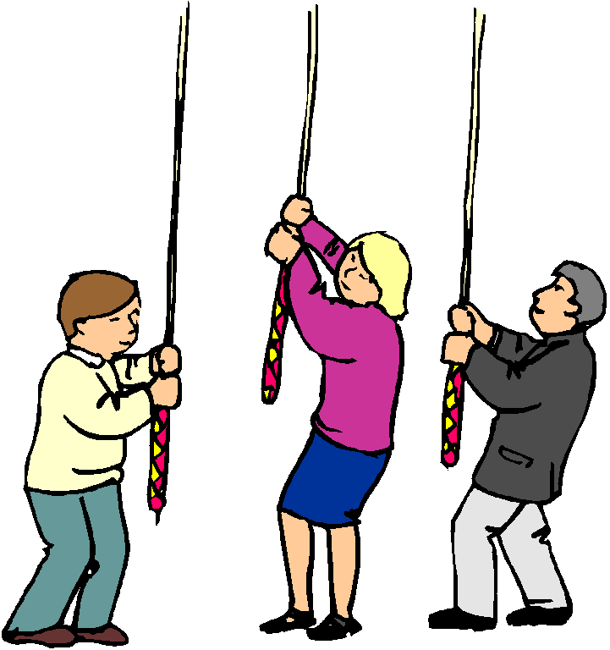
The Bell Ringers start ringing the bells as soon as the Bride and Groom reach the church door after the ceremony. They usually ring the bells for 20 minutes, and once started they cannot stop in the middle. In the unlikely event of being unable to get enough ringers, we will refund any cost already paid.

Rehearsal

We usually rehearse in the evening a day or two before your wedding. At a minimum we need the bride and groom. We have found that those involved in the ceremony like to practice, however small their roles. You will therefore want to check the availability of your best man, bridesmaids and groomsmen (at least one of each), father of the bride and any flower girls or page boys.

Car Parking

Car parking near the church building is very limited but there are plenty of streets in the locality where your guests can park. It is the responsibility of your groomsmen to ensure that the day runs smoothly. They will need to be in the church building to hand out service sheets and show people to their seats. We also suggest that your groomsmen reserve parking beside the church grounds on Church Lane for less physically able relatives.

Seating arrangements

It’s up to you where your guests sit. Some couples like to have the groom’s family sitting on the right hand side and the bride’s on the left hand side, others just say ‘sit where you like’ and some families know that they can’t sit Auntie Mary next to cousin Anne. Appendix 6 is the seating plan for the building. You can then annotate it and give it to your groomsmen, so that they know where to sit family members.

Wedding Flowers

We hope you will have a very happy and memorable day, and we wish you every happiness together in the future. At St Andrew’s Church the Flower Guild are responsible for organising any flowers you may wish to have in the church building on your wedding day. Please do not make any additional arrangements.

Please contact the Flower Guild - Mrs Pam Lawford - to arrange a meeting. You can then discuss with her the sort of flowers you would like for your wedding at St Andrew’s. We do not usually use any other florists. The Flower Guild has great experience with our building and do a wonderful job.

[Mrs Pam Lawford – 01482 653073]

Please have an initial meeting with her as soon as possible.


Mrs Lawford will probably want to meet you in the church building itself so that you can choose the location of your flowers. She has a map of the church building showing the usual locations for flower arrangements. She has a list of prices for flowers and for the flower arrangements.

Where there is more than one wedding on the same day we invite you to make your own arrangements with the other families involved, to share the cost between you as far as possible, and to reach a compromise solution if your requirements are significantly different from each other.

The Flower Guild will give you a quotation for the cost of the flowers and other materials. Payment for the flowers should be made at the same time as the rest of the fees are paid. Please make cheques for the flowers payable to the St Andrew’s Church alternatively you can pay by bank transfer. Details can be obtained from the Church Office. Thank you.

The ladies of the Flower Guild love arranging the flowers for Weddings, and look forward to decorating the Church building for your own wedding day. They wish you every happiness and God’s blessing on your married life together.

After your wedding service the flowers remain in the church building for a week.

Crèche


We believe a marriage blesses the whole community. As such, we love having children at weddings. If you have young children at your wedding service parents may like to know that there are crèche facilities through the door at the back of the building.

Boxes of toys and children’s books can be found in clear plastic tubs. Toilets and baby changing facilities can be found through the door at the back of the building.

Please encourage your guests to use these facilities if they have young children but we do ask that the crèche is left as it was found and any used nappies are taken away and disposed of at home.

Photographers

We want to ensure that you and your friends and family are not distracted as you make your vows and celebrate your marriage. So we have some rules which we will ask your photographers to abide by. We ask that they remain within the area of the pews or at the back of the building at all times and to refrain from moving around too much during the service. Most professional photographers know what is acceptable in church and will understand, but we have had experiences of weddings when the photographers have moved around so much they have become centre stage, not the couple being married. Couples have understandably been upset. We are happy to speak to photographers before the service to outline these rules to ensure that you have the best possible day.

Video

Some couples like to have a video recording of their wedding day and this can be done by a professional video recordist or a family friend. Whoever does the recording will need to obtain a Limited Manufacture Licence (LM) and complete our video paperwork. The fee for recording your service at St Andrew’s is £75.00. If you’re considering having a video of your special day, please ask the church office to send you the appropriate paperwork.

Confetti

Yes, your guests can throw confetti but we do ask that this isn’t done until you reach the steps by the pub. Please ask your guests to avoid shiny permanent plastic confetti and use organic confetti which is much better for the environment and the wildlife in the churchyard. How about having bubbles instead?

Wedding Checklist

Attended marriage preparation
Fees paid – 3 months before wedding date
Wedding flowers
Banns arranged at other church(es)
Banns certificate forwarded to Liz
Service sheets | Entrance music chosen
Service sheets | Hymns chosen
Service sheets | Copyright details included
Service sheets | Bible reading
Service sheets | CCL number included
Service sheets | Copy of service sheet emailed to Liz for checking
Organist contact – Tony Brown
Video paperwork sent to Liz
Clergy visits

Useful numbers

Ash Carter The Rectory, 2 School Lane, Kirk Ella 01482 653040
John Telford The Vicarage, 2a Chestnut Avenue, Willerby 01482 575232

Liz Telford St Andrew’s Church Office 01482 654713
Office open 10 am – 12 noon
Tuesday and Thursdays
kirkellachurchoffice@gmail.com

Tony Brown 07715 457857

Pam Lawford 01482 653073

The Parochial Church Council of the Ecclesiastical Parish of St Andrew, Kirk Ella in the Diocese of York. Registration No 1130514

